-

Harrington Park 5K Fall Spectacular
PO Box 83
Harrington Park, New Jersey 07640

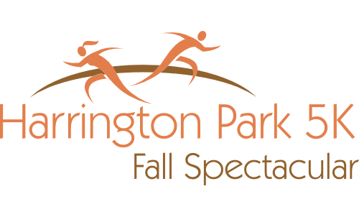
Home of the 2022 Master’s Men Championship – NJ

USATF Certified Course & Sanctioned

Benefiting
HP Volunteer Ambulance * HP Fire Dept
HP Public School * HP Library
Scholarships & Community
Saturday November 12th, 2022
Harrington Park New Jersey
www.hp5k.org

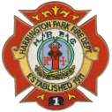
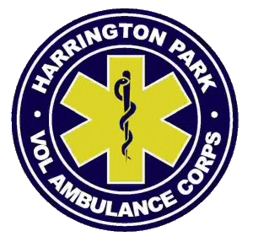
RAIN OR SHINE

Fall Spectacular
Amenities

Events: 5K “Fall Spectacular” Run & Walk
Mile Fun Run (ages 9 and under)
Kiddie Dash (ages 6 and under)

Course: The 5K course is a USATF Certified “relatively flat” road course with two waters stops through Scenic Harrington Park.
Location: Harrington Park School
191 Harriot Avenue, Harrington Park, NJ

When: Saturday, November 13th, 2022
- 8 am Same Day Registration
- 9 am Kiddie Dash
- 9:15 am Mile Fun Run
- 10 am 5K Run & Walk Start
- 11 am Awards

Questions: Email us at hp5k@optonline.net

Website: www.hp5k.org

Course Map: Available on our website

Registration and Bib Pick-up

Mail: HP Road Runners Association, Inc. PO Box 83 Harrington Park, NJ 07640
On-line: www.hp5k.org or www.bestrace.com
Bib Pick-up and In-person Registration:
HP School Gym - Friday 11/11 (5pm – 8pm)
- Race Day 11/12 (8am-9:45am)
RAIN OR SHINE

- Long sleeve “tech tops” to the first 500 pre-registrants, and while supplies last, for the 5K
- Cotton T-shirts for all Mile Fun Run and Kiddie Dash participants
- Large Warm Gym for Pre-Race & Awards
- Clean Indoor Restrooms (No Portable Units)
- Well established course, water stations at 1st and 2nd Mile Clocks
- Ample Parking – HP Borough Hall, OLV Church, Community Church, St Andrews Church

Awards

- Top 3 M & F Overall

- Top 3 M & F per age group in 5 year
age groups, 9 & under through 85+
- Top 3 M & F HP Residents
- Top M & F Harrington Park School Students (K-8)
- Top 3 Harrington Park Fastest Families (using aggregate of immediate family 3 fastest times)

Fees

Postmarked by 10/16 After 10/16 Adult $ 25 $ 30 USATF-NJ Members $ 22 $ 27 Students 14 & Under $ 20 $ 25 Mile Fun Run 9 & Under $ 10 $ 10 Kiddie Dash 6 & Under $ 5 $ 5
Make checks payable to: Harrington Park Road Runners Association
Fall Spectacular Official Entry Form

The HP5K Fall Spectacular is open to all abilities: racers, runners, slow joggers and walkers
Event: 5K Mile Fun Run Kiddie Dash
Last Name: _____________________________
First Name: _____________________________
Address: _______________________________
City: _______________ State: _____ Zip:_____
Phone: _________________________________
E-mail: _________________________________
Age (on 11/13/2021): ________ Sex (M/F) ____
Date of Birth (MM/DD/YYYY)_________________
USATF-NJ # _______________________________
Current Harrington Park School Student? Yes Harrington Pk Fastest Family Team Member? Yes
T-shirt size for 5k participants (Circle your choice):
Men’s sizes: S M L XL XXL Womens: S M L
****** Sign the Waiver ******
In Consideration of this entry being accepted, I hereby for heirs, executors, administrators, and myself waive any claims that I may have against Harrington Park Road Runners Assoc., Borough of Harrington Park (HP), HP Volunteers Ambulance Corp, HP Police Dept., HP Board of Education, HP School or their representatives, successors, or assignees for any injuries that may be suffered by me in this event. I certify that I am in physical condition for this event.

Signature: (parent or guardian if under 18)
__________________________ Date ____________

